CONSENT FORM

Changing Minds: Cognitive Responses to Addiction-Related Cues during Substance Dependence Recovery

We are asking you to take part in a research study. You have been chosen to participate in this study because you are a reasonably healthy adult who falls into one of the two groups who will be taking part in this study: group 1) people who are currently participating in a substance dependence treatment program or group 2) people who do not have a history of abusing alcohol and drugs. You are being asked to take part in this study in order to help us better understand the effects of long-term substance use on thinking abilities and the ways in which people relate to each other. We ask that you read this form and ask any questions you may have before agreeing to participate in the study. This study is being conducted by Dr. Natalie Ceballos, a faculty member in the Department of Psychology at Texas State University, 601 University Drive, San Marcos, Texas 78666. Dr. Ceballos may be contacted by phone at (512) 245-8709 and by e-mail at nc18@txstate.edu. This study is being funded by a grant from the Texas State University Research Enhancement Program to Dr. Ceballos.

In this study, researchers will monitor your brain activity while you look at pictures on a computer screen. You will also be asked to complete a number of questionnaires, which will ask about basic information (age, ethnicity, gender, etc.), as well as your mood, personality characteristics, the amount of alcohol and drugs you consume or have consumed, and your feelings about alcohol and drugs. The study consists of weekly sessions lasting about one hour (45 minutes of questionnaires plus 15 minutes of computer tasks and monitoring of brain activity). The results will contribute to understanding the effects of several substances and contribute to improved treatment programs and recovery. About 50 people will participate in this study.

In order to decide whether or not you want to be part of this study, you need to know enough about its risks and benefits in order to make a decision to participate or not. This consent form gives you detailed information about the study, which a member of the research team will also discuss with you. By reading this form and talking to the researchers, you will learn about the different aspects of this research: its purpose, the procedures that will be performed, any risks of the procedures, and benefits of being in the study. Once you fully understand the study, you will be asked if you want to participate. If you decide that you do want to participate, you will be asked to sign this consent form.

Description of the Procedure: In this study you will be asked to do two things each week for up to four weeks.
- First, you will be asked to complete pencil-and-paper questionnaires, which will ask about basic information (age, gender, ethnicity, etc.), your mood, personality characteristics and whether or not you have a history of drinking alcohol and/or using drugs on a regular basis. Also, you will be asked to provide (in writing) information regarding your feelings about alcohol and drugs (approximately 100 questions). In previous studies, participants required about 45 minutes to complete the questionnaires in this experiment.
- Next, you will be fitted with a headband that holds two plastic discs in place on either side of your head. A non-toxic, salty gel will be placed between the discs and your skin. This method uses the same Doppler technology as a standard ultrasound machine, which one might encounter in a doctor’s office. Through these harmless plastic discs, researchers will continuously monitor flow within specific blood vessels in your brain while you look at a variety of pictures on the computer screen. Picture categories may include images of people, household items, alcohol, drugs, shapes, etc. Example pictures are given at the end of this consent form. This portion of the experiment will require approximately 15 minutes to complete.
Risks: There are no known risks associated with looking at pictures other than what is required for prolonged concentration, which could result in fatigue. Some participants may experience slight discomfort from wearing the fitted headband that contains the plastic discs. The salty gel that will be placed between the discs and the skin is similar to salt water (saline) and is unlikely to cause irritation or allergic reaction. However, if you become uncomfortable at any time during your time in the lab, let the researchers know and the study will be stopped.

Also, if you find the pictures used in this study to be overly upsetting or distressing, please inform the researcher so that they can end the testing session. These pictures are of common items that you might see on a daily basis, so we do not expect that they will be too distressing. However, if for any reason you feel distressed or upset, the experiment will end. At the end of the consent document, we have included examples of the types of pictures you might see in this study.

You will be asked to provide information about how much you drink or use drugs and how often you drink or use drugs, as well as your feelings about alcohol and drugs. It is also important to note that you may choose not to answer any question for any reason. To give you an idea of the types of questions you might see in the questionnaire, we have provided some examples below.
Example questions:
- Have your parents or other family members ever had a problem with alcohol or drugs?
- Have you used / Do you use alcohol or drugs? If so, approximately how much and how often?
- How much do you agree with these statements?
  - If I were under the influence from drinking alcohol, it would be easier to talk to people.
  - If I’m drinking, it’s easier to express my feelings.

All of this information will be held in the strictest confidence. Your information will be coded with a participant number and stored separately from your name or other identifying information in locked offices. Only the researchers and their assistants will have access to this information. In the even that results of the study are published or presented at a conference, the information obtained from the study will be presented in aggregate – in other words, specific people’s data will not be identifiable. Additional information about confidentiality is given later in this document.

If you are participating in this research study while undergoing inpatient treatment for alcohol or drugs, and if you find any part of this study to be too upsetting or distressing, or if immediate care is needed, your counselor or other treatment provider will be notified, and care will be provided through the facility.

If you are a student at Texas State University at the time that you participate in this study, and if you find any part of this study to be too upsetting or distressing, and if immediate care is needed, it is available at the Health Center at Texas State University (behind LBJ Student Center and Jackson Hall). Phone: day: 512-245-2161, after hours: 512-245-2167. Psychological assistance may be obtained at the University Counseling Center. Location: 5-4.1 LBJ Student Center; Phone: 512-245-2208; E-mail: counselingcenter@txstate.edu. Mental health services at TX State are free to students, but number of sessions allowed may be limited. For information concerning Al-Anon and Alcoholics Anonymous groups on the campus of Texas State University and in the surrounding area please call the Alcohol and Drug Resource Center, 5-4.1 LBJ Student Center; Phone: 512-245-3601; Email: adrcoffice@txstate.edu.

Further information concerning your rights as a research participant can be obtained from the Texas State University Institutional Review Board at (512) 245-2314 or IRB@txstate.edu.

Benefits: One of the benefits of participating in this study is the sense of satisfaction that comes with contributing to a study that may further scientific knowledge about the effects of long-term substance use on thinking abilities and the ways in which people relate to each other.

Compensation: If you are participating in this study while you are an inpatient at an alcohol/drug treatment facility, you will be compensated at the rate of $10/weekly session (up to $40; that is, 4 weekly sessions). These funds will not be released to you as cash, but you will be issued “credit” for purchases that you are allowed to make during treatment.

If you are completing these questionnaires at Texas State University, you have a choice between receiving $10/weekly session up to $40 (that is, 4 weekly sessions), or extra course credit at their instructor’s discretion (e.g., you may choose payment or extra credit, but not both). If you choose not to participate in this study, you may still be entitled to gain extra credit for these courses by participating in other experiments, attending talks or events on campus, or completing short written assignments (e.g., movie reviews, thought papers). Check with you instructor for more information about your options.

Right to Withdraw: At any time, you may choose not to be in the study. If you withdraw from the study, no new data about you will be collected. You may also withdraw your agreement for us to use your data that have already been collected (other than the data needed to keep track of your withdrawal). You may do this by informing the researcher (Dr. Natalie Ceballos) of your decisions on the phone, by e-mail or in a letter.

Your decision not to participate, or to withdraw from the study, will not involve any penalty or loss of benefits to which you are entitled. If you decide to withdraw, we ask that you contact Dr. Natalie Ceballos in the Psychology Department at Texas State University, San Marcos, TX 78666. At that time, you will be asked for your permission to continue using the information about you that has already been collected prior to your withdrawal.

Early withdrawal will not penalize your relationship with the Department of Psychology or Texas State University.

Confidentiality:
All of your data will be coded with a participant number so that your answers to the questions in the study will not be linked with your name. Within Texas State University, your research records will be stored in locked offices within the Department of Psychology and only the researchers will have access to your data. Your research records will not be released without your consent unless required by law or court order. The data resulting from your participation may be used in publications and/or presentations, but your identity will not be disclosed. Paper copies of study materials will be retained for a period of up to 3 years after the completion of the study, after which these items will be destroyed.

You may gain access to your data by making a written request to the researchers using the contact information given in the consent document. A signed, written request is required in this case in order to verify your identity before releasing data. Requests for personal data access and/or questions concerning the study may be directed to Dr. Natalie Ceballos in the Department of Psychology, Texas State University, 601 University Drive, San Marcos, TX 78666. Dr. Ceballos may be reached by phone at (512) 245-8709 and via e-mail at nc18@txstate.edu.

For questions regarding your rights as a research participant, contact the Texas State University Institutional Review Board at (512) 245-2314, Dr. Jon Lasser (512-245-3413; lasser@txstate.edu), and/or Ms. Becky Northcut , Compliance Specialist, 512-245-2102.

Statement of Consent: “The purpose of this study, the procedures to be followed, risks and benefits have been explained to me. I have been allowed to ask any questions on my mind, and my questions have been answered to my satisfaction. I have been told to contact Dr. Natalie Ceballos in the Department of Psychology at Texas State University if I have additional questions or concerns. I have read this consent form and agree to be in this study, with the understanding that I may withdraw at any time. I have been told that I will be given a signed copy of this consent form.”

________________________________________________________________________
Participant’s Name (PRINT)

________________________________ __________________
Participant’s Signature Date

___________________________________________
Signature of Person Obtaining Consent
Date:_______________
For Texas State University Students Only:

I choose to receive the following form of compensation for participation in this study (circle one):

$10 per weekly testing session OR extra credit in _______________________________
(write course & instructor here)
Picture Examples:

In this study you might see pictures that fall within the following categories:

Pictures of Food: Pictures of People: Pictures of Beverages:



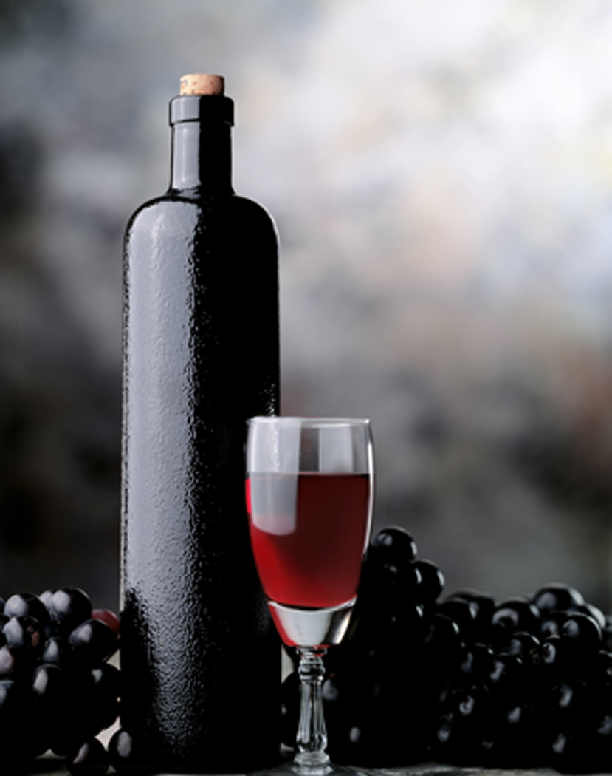




Pictures of Objects: Pictures of Shapes: Pictures of Activities:



Pictures of Complex Scenes:


